

**EVALUATION OF INTERNSHIP REPORT**

## B.Tech: III Year

**Department of Computer Science & Information Technology**

**Name of the Student – Kanak Joshi**

**Branch & section - CSIT-2**

**Roll No - 0827CI201090**

**Year-2022-23**

## Department of Computer Science & Information Technology

**AITR, Indore,**

**ACROPOLIS INSTITUTE OF TECHNOLOGY & RESEARCH, INDORE**

# Department of Computer Science & Information Technology

**Certificate**

Certified that training work entitled “*Cyber Security*” is a bonafied work carried out after sixth semester by “*Kanak Joshi*” in partial fulfilment for the award of the degree of Bachelor of Technology in Computer Science and Information Technology from “*Prof. Nidhi Nigam (CEH certified)*” Acropolis Institute of Technology and Research during the academic year 2022-23.

*Name and Sign of Training Coordinator Name & Sign of Internship Coordinator*

**ACROPOLIS INSTITUTE OF TECHNOLOGY & RESEARCH, INDORE**

# Department of Computer Science & Information Technology

**ACKNOWLEDGEMENT**

I would like to acknowledge the contributions of the following people without whose help and guidance this report would not have been completed. I acknowledge the counsel and support of our training coordinator, *Prof. Nidhi Nigam (CEH certified)* , CSIT Department, with respect and gratitude, whose expertise, guidance, support, encouragement, and enthusiasm has made this report possible. Their feedback vastly improved the quality of this report and provided an enthralling experience. I am indeed proud and fortunate to be supported by him/her. I am also thankful to Dr. Shilpa Bhalerao, H.O.D of Computer Science Information Technology Department, for her constant encouragement, valuable suggestions and moral support and blessings. Although it is not possible to name individually, I shall ever remain indebted to the faculty members of CSIT Department, for their persistent support and cooperation extended during this work.

*Name – Kanak Joshi*

*Enrollment No. – 0827CI201090*

### ACROPOLIS INSTITUTE OF TECHNOLOGY & RESEARCH, INDORE

### INDEX

S.no CONTENTS Page no

1. Introduction to technology Undertaken…….... 1

2. Objectives ………..……………………………….... 3

3. Project undertaken ……………………….. 4

4. Screenshots of Project and Certificates……………………….. 11

5. Github Links (Project/certificate/video/copy of report.… ……. 12

7. Conclusion……….. ……………………………………. 16

8. References/ Bibilography………………………………..…………… 17

**Introduction to technology Undertaken**

**( Cyber Security)**

[Cyber security](https://onlinedegrees.unr.edu/blog/cybersecurity-or-cyber-security/) is currently one of the fastest growing and most in-demand industries in terms of employment opportunities. There are several reasons for this quicker-than-average growth across nearly every type of cyber security career. This includes the fact that cyber attacks are increasing at an unprecedented rate, and the malicious actors behind these infiltrations are continuously coming up with new attack strategies.

Often, all that stands between an organization and a full-scale, damaging data breach are internal cyber security professionals and the tactics they put in place for protection. Beyond just guarding against unauthorized access, these cyber security professionals are also responsible for maintaining continuous uptime of the organization’s most crucial IT assets while supporting these platforms’ top-notch performance for end users.

The types of cyber security jobs available in today’s market are multi-disciplinary and touch every department of the business. Organizations from enterprises and small businesses to government agencies now need highly trained and knowledgeable IT and cyber security personnel to guard against attacks and support the technologies that underpin daily operations.

In today's digital world, cybersecurity has become an essential part of every company's strategy for sustainability, security, and growth. As businesses grow, the demand for cybersecurity talent will only continue to grow in 2023 and beyond.

Cyber security is a growing industry that is still in need of skilled professionals. The global cyber security market is expected to grow from $170 billion in 2017 to $202 billion in 2023.

The demand for cyber security jobs has risen significantly over the past few years. More than 1 million cyber security jobs will be available by 2023, but less than 400,000 cybersecurity professionals will be trained by then. Cyber security is an ever-growing industry. It is projected to grow by 11% in 2023 and by 20% in 2025. This is a fast-paced career with a median salary of $81,000.

**Objectives**

The objective of Cybersecurity is to protect information from being stolen, compromised or attacked. Cybersecurity can be measured by at least one of three goals-

1. Protect the confidentiality of data.
2. Preserve the integrity of data.
3. Promote the availability of data for authorized users.

These goals form the confidentiality, integrity, availability (CIA) triad, the basis of all security programs. The CIA triad is a security model that is designed to guide policies for information security within the premises of an organization or company. This model is also referred to as the **AIC (Availability, Integrity, and Confidentiality)** triad to avoid the confusion with the Central Intelligence Agency. The elements of the triad are considered the three most crucial components of security.

The CIA criteria are one that most of the organizations and companies use when they have installed a new application, creates a database or when guaranteeing access to some data. For data to be completely secure, all of these security goals must come into effect. These are security policies that all work together, and therefore it can be wrong to overlook one policy.

## 1. Confidentiality

Confidentiality is roughly equivalent to privacy and avoids the unauthorized disclosure of information. It involves the protection of data, providing access for those who are allowed to see it while disallowing others from learning anything about its content. It prevents essential information from reaching the wrong people while making sure that the right people can get it. Data encryption is a good example to ensure confidentiality.

## 2. Integrity

Integrity refers to the methods for ensuring that data is real, accurate and safeguarded from unauthorized user modification. It is the property that information has not be altered in an unauthorized way, and that source of the information is genuine.

## 3. Availability

Availability is the property in which information is accessible and modifiable in a timely fashion by those authorized to do so. It is the guarantee of reliable and constant access to our sensitive data by authorized people.

**Project undertaken**

**( Windows Password Reset using cmd)**

Step 1: Prepare a Windows 10 setup disk  
If you don’t have a reset disk, you can create one with media creation tool on another workable computer.

Step 2: Boot up password locked computer  
Inset the reset disk to the locked computer and then power on your PC. When vendor logo appears, choose Boot Option Key repeatedly until the Boot Option Menu shows up. Find the suitable Boot Option Key for your computer and choose the USB drive to boot your computer.

Step 3: Replace Utility Manager with Command Prompt

* After the computer boots up from installation disk, press “Shift + F10” to bring up command prompt.
* Now you can execute command below to replace utility manager with command prompt  
  ***move d:\windows\system32\utilman.exe d:\  
  copy d:\windows\system32\cmd.exe d:\windows\system32\utilman.exe***

* Take out the setup disk and restart computer after the commands are executed

Step 4: Reset Windows 10 local admin password with command prompt

* When the login screen appears, click on the Ease of Access icon on the lower-right corner, the command prompt will show up
* Type the following password reset command in the windows and hit Enter to set a new password  
  ***net user***

Step 5: Restore Utility Manager

* Insert the reset disk into computer and click the Power icon to restart
* When computer boots up from the disk, press Shift + F10 to open command prompt
* Type command ***"copy d:\utilman.exe d:\windows\system32\utilman.exe"***, press Enter, and then type "Yes" to restore Utility Manager.

Step 6: Login Windows 10 with local admin account  
Close the command prompt window and reboot Windows 10 computer. Login with the admin account you have reset password successfully.

**Screenshots of Project and Certificates**

* + - **Project screenshots :-**

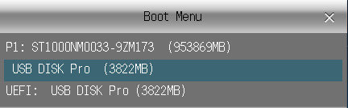

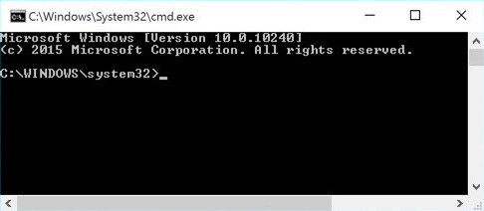

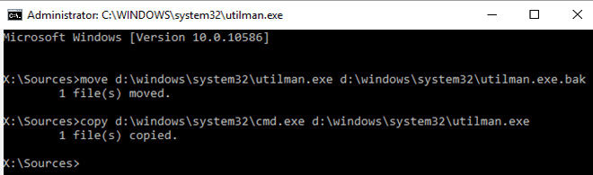

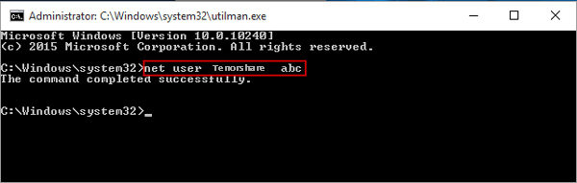

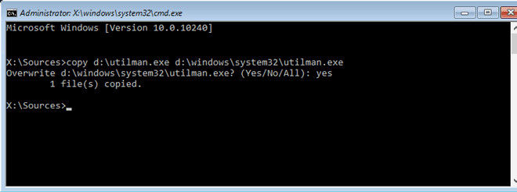

* **Screenshot of certificate :-**

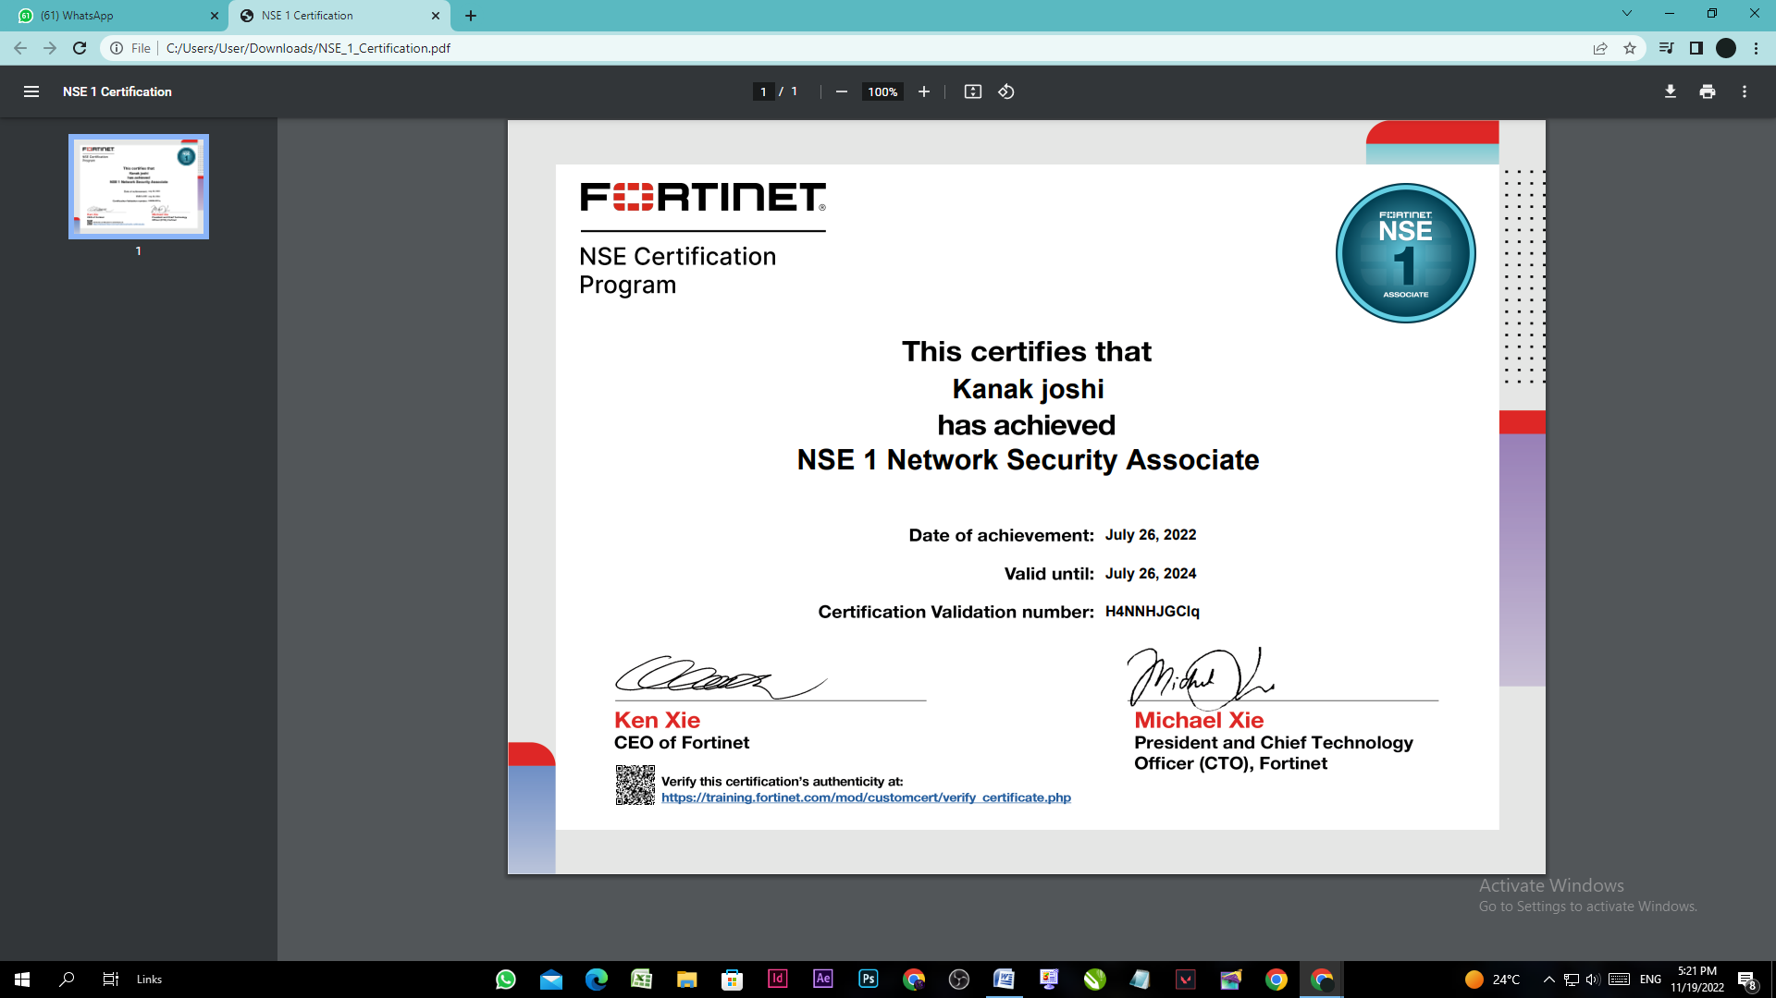

**Github Links (Project/certificate/video/copy of report)**

* **Project –** https://github.com/kanak130902/Evaluation_of_Internship
* **certificate-** https://github.com/kanak130902/Evaluation_of_Internship/blob/main/NSE_1_Certification.pdf
* **video-**
* **copy of report-**

**Conclusion**

As threats and protection measures continue to become more complex and sophisticated, it’s important for employers to find candidates with in-depth knowledge into cyber security and other highly relevant areas. In this way, while a bachelor’s degree may suffice for some types of cyber security careers, the most attractive candidates are those who hold master’s degrees.

Those interested in these or other types of cyber security careers can put themselves on the path to employment by obtaining a high-level degree. The Online Cybersecurity, Master of Science program at the University of Nevada at Reno provides students with the skills, experience and expertise they need to pursue an array of exciting and high-compensating cyber security careers.

**References**

[**https://adamtheautomator.com/**](https://adamtheautomator.com/)

[**https://training.fortinet.com/auth/saml2/selectidp.php**](https://training.fortinet.com/auth/saml2/selectidp.php)

[**https://4sysops.com/**](https://4sysops.com/)

[**www.youtube.com**](http://www.youtube.com)